Task
1. Use the restcountries API to make GET request and POST request and host in heroku

GET call works directly in the browser or in postman
whereas to make POST call we need id parameter in all the countries details.

Id parameter is added in db.json using the code in Add_ID_to_API.js or Add_ID_to_API.py

After the ID is added. The code in json-server-heroku is hosted in heroku following the steps in below link,
https://github.com/reach2arunprakash/json-server-heroku
Heroku link after hosting the code:
https://powerful-everglades-42955.herokuapp.com/

Hosted in Heroku

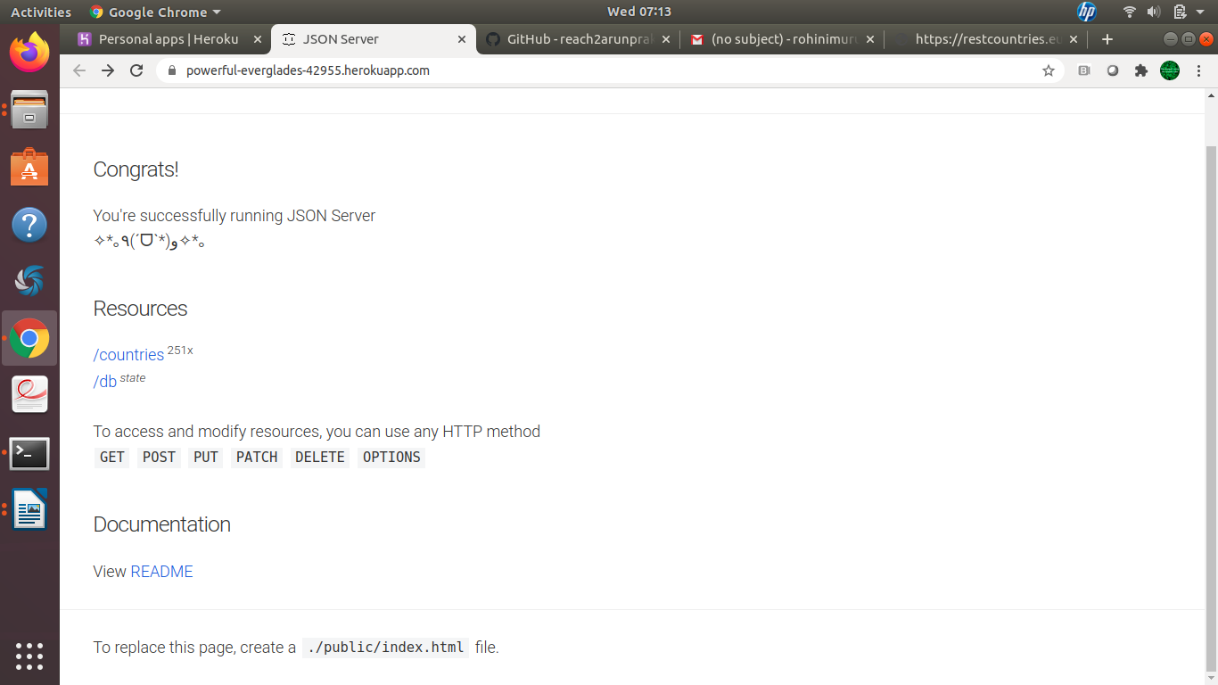

Opening in browser – GET call

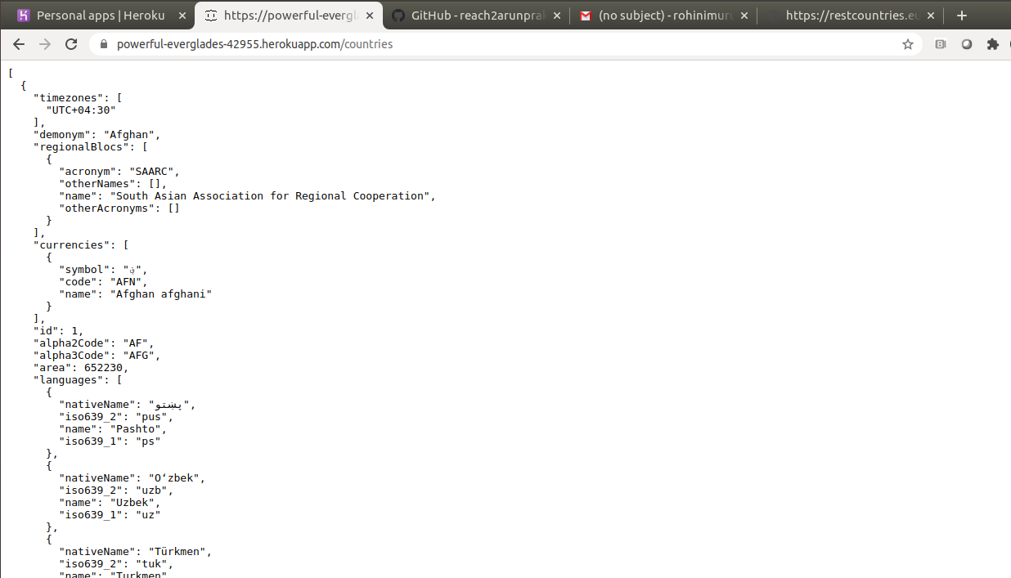

Post Call

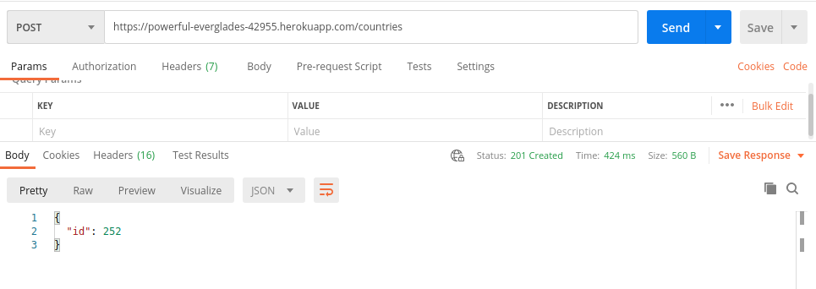

GET call with specific id value

